***Assignment – 11***

Subqueries.

1. Write a query that uses a subquery to obtain all orders for the customer named Cisneros. Assume you do not know his customer number (cnum).

Ans 1)

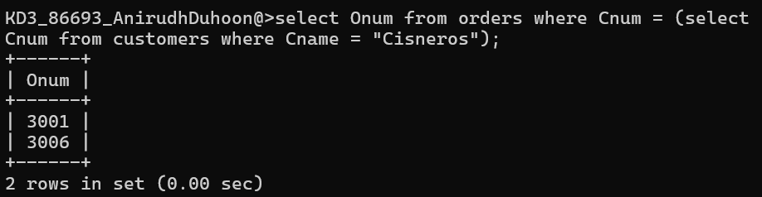

1. Write a query that produces the names and ratings of all customers who have above-average orders.

Ans 2)

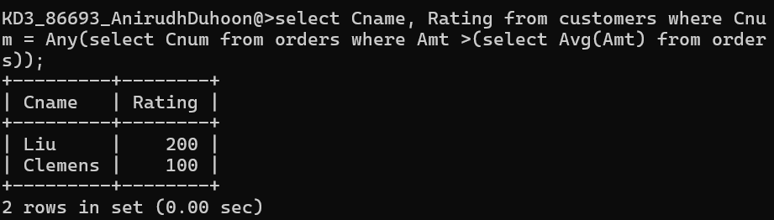

1. Write a query that selects the total amount in orders for each salesperson for whom this total is greater than the amount of the largest order in the table.

Ans 3)

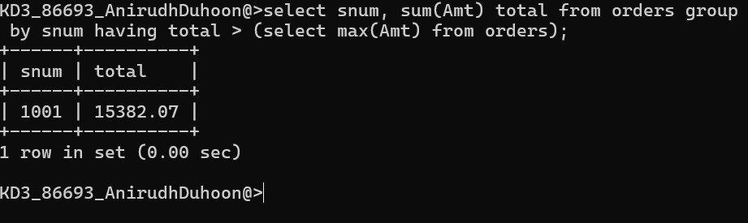

*Sameer Dehadrai* Page: 1